# Stage 1: Acquiring Required Parts for Scale

The following is a list of all the components you will need to construct the scale:

* 1 Arduino Uno
* 1 HX711 Load Cell Amplifier
* 1 100 g Load Cell
* Jumper wires
* 1 Mini breadboard
* 1 microSD Card Reader Module
* 1 MicroSD Card
* USB Printer Cable
* 8 M3 12 mm screws
* Gel cup

You will need the following tools:

* Soldering iron
* Super glue
* Heat gun
* Heat shrink tubing

You will also need to 3D print the following pieces:

* **Base Plate**

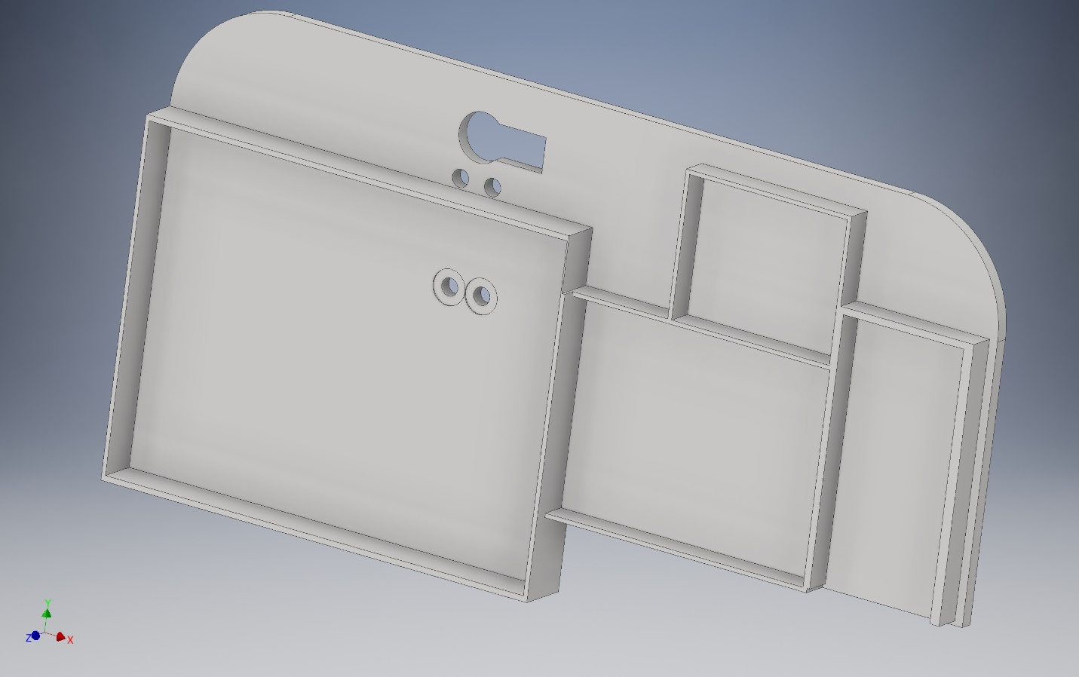

* **Base Plate Bottom**

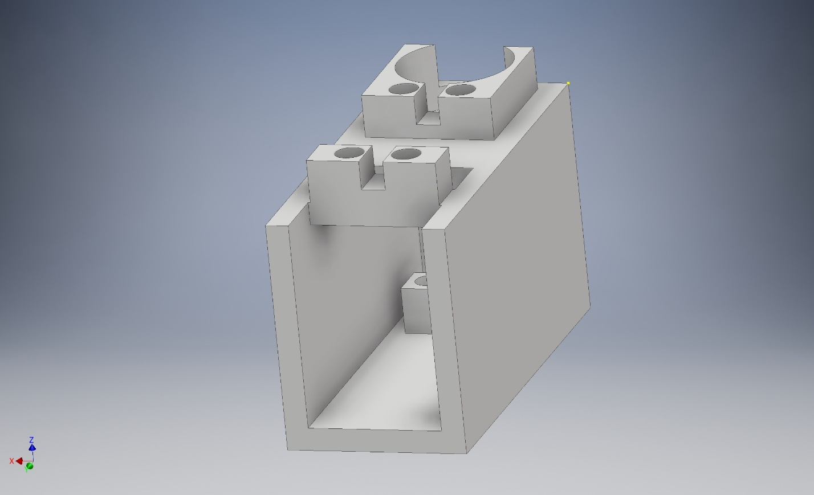

* **Gel Cup Holder**

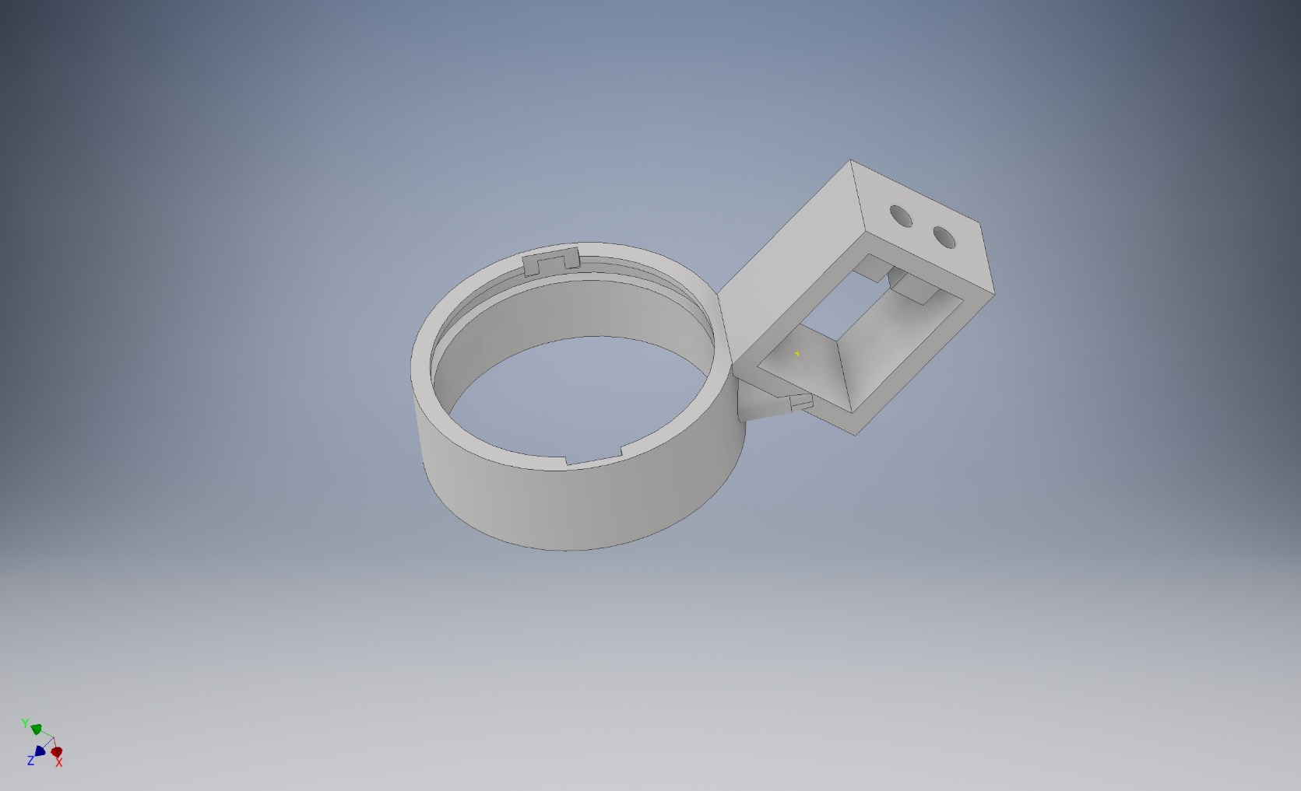

* **Gel Cup Holder Top**

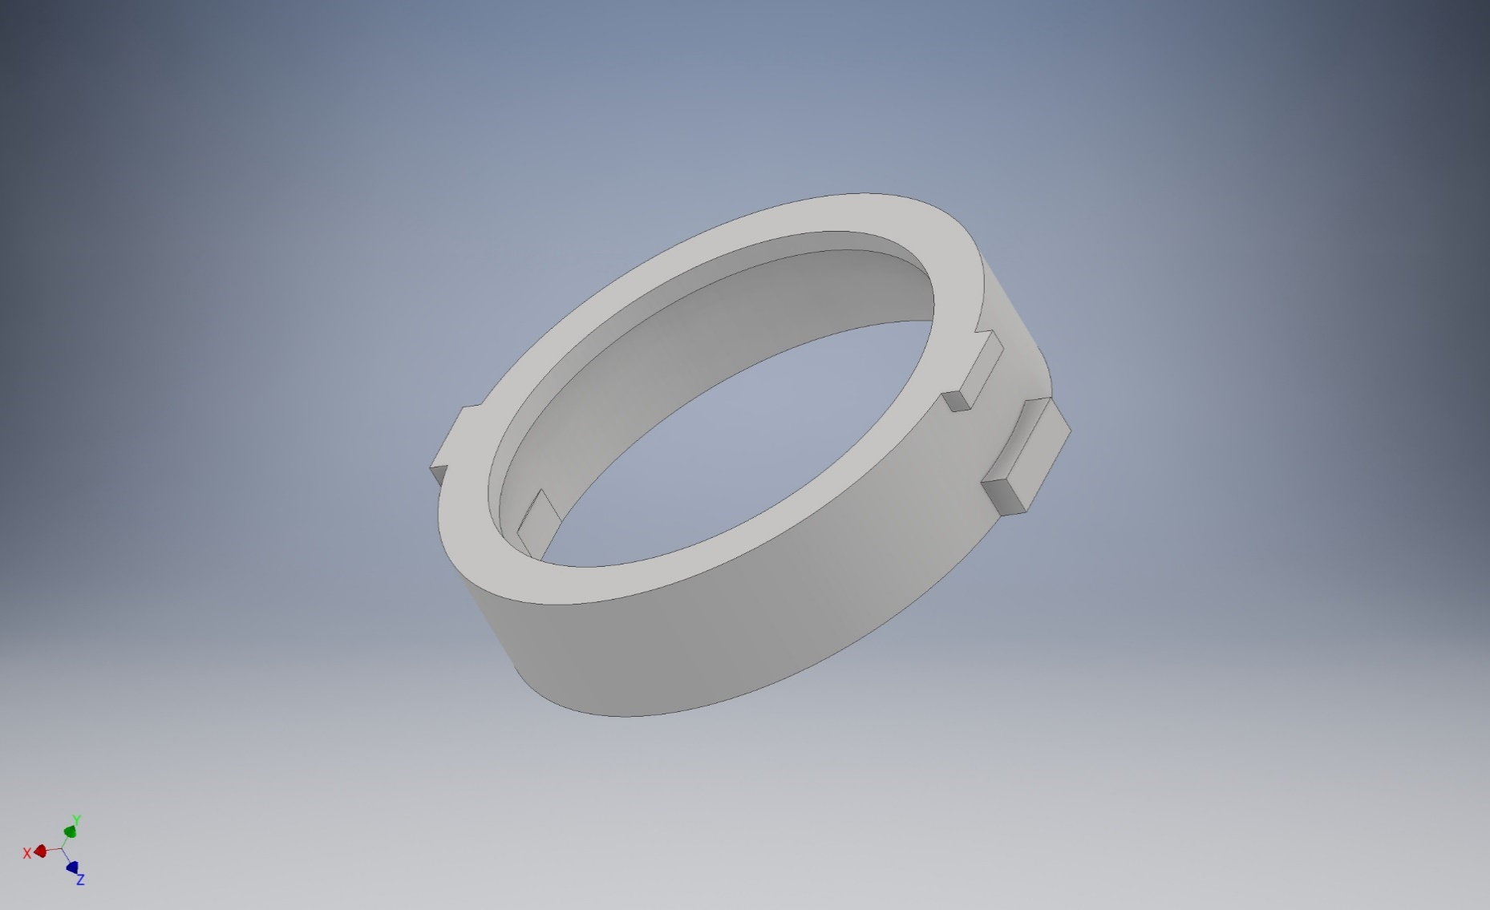

The CAD files for the 3D prints can be found in the supplementary materials. Instructions on how to assemble the circuit will follow later.

A table listing where you can find certain components can also be found in the supplementary materials.

# Stage 2: Preparing the Components

The load cell and the load cell amplifier will both require some soldering and other modifications.

The load cell amplifier will need to have the breakaway header pins soldered on and 90 degree breakaway headers may be used for the load cell pins to facilitate wired connections in the circuit, but are not necessary.

The leads on the load cell are very fragile and must be handled carefully.

1. Use superglue on the base of the load cell and the wires to strengthen that area, since it is the most fragile and likely to break.
2. Strip the ends of the leads on the load cell so that about half an inch of wire is exposed.
3. Take two female-female jumper wires and cut them both in half and strip the ends of the wires so that about half an inch of wire is exposed.
4. Wrap the exposed wire from each of the load cell leads with the exposed wire of one of the halves of the jumper wires.
5. Use a soldering iron to solder each of the connections together.
6. Use the small heat shrink tubing to cover all the exposed wire for the individual load cell leads.
7. Use the large heat shrink tubing to group all four of the soldered connections together, leaving about a quarter of an inch of the bottom of the small heat shrink tubing exposed for each of the leads.

To prepare the gel cup itself, fit the gel cup inside of the gel cup holder top piece. It should fit tightly but may require some additional superglue to secure the connection. It should be able to fit inside the gel cup holder piece. Once you put the gel cup in the holder, rotate it 90 degrees to lock it in place. It should still be able to rotate but will not removable from the gel cup. To remove it, simply twist until the tabs of the gel cup holder top piece are aligned with the notches in the gel cup holder.

# Stage 3: Scale Assembly

1. Place the baseplate on the wire cage top
2. Insert the wired end of the load cell in the base plate bottom and align the holes of the load cell with the holes on the bottom of the base plate bottom piece. Insert screws through the base plate bottom holes and the load cell holes, ensuring that the load cell remains level.
3. Feed the wires from the load cell through the large hole in the top of the base plate bottom
4. Place the other end of the load cell underneath the holes from the gel cup holder and align the gel cup holder holes with the load cell holes
5. Insert screws from the top of the gel cup holder.
6. From underneath the wire cage top, align the four holes and the large hole with the wires from the base plate bottom piece with the four holes and the large hole in the base plate. Feed the wires from the load cell through the large hole of the base plate.
7. Insert screws into the four holes in the base plate, ensuring that the base plate bottom piece remains level.

The scale assembly should be secure on the wire rack.

# Stage 4: Configuring the Circuit

Make the following connections on the circuit components:

## Arduino and Breadboard:

Since multiple components will require a positive power supply and ground pins, make positive and ground power rails on the breadboard. The following figure is one suggestion of how to do this.

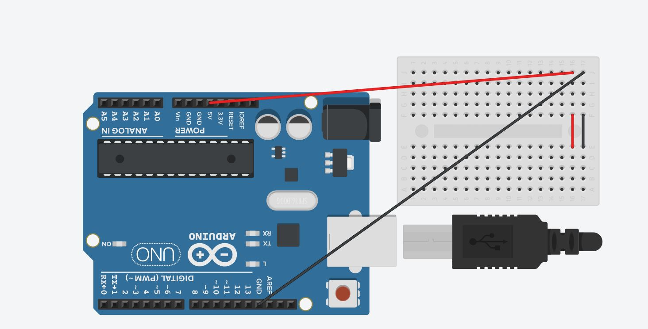

## Load Cell Amplifier:

Connect:

**Load Cell Amplifier -----> Arduino**

VCC --------------------------> Vcc

DAT--------------------------> Pin 6

CLK---------------------------> Pin 7

GND -------------------------> Gnd

**Load Cell Amplifier ----> Load Cell**

RED ------------------------> Red wire

BLK ------------------------> Black wire

WHT ----------------------> White wire

GRN -----------------------> Green wire

Use jumper wires and the breadboard as necessary to make the connections with the Arduino. Note that to reduce the number of wires, the load cell amplifier headers could be connected directly to the breadboard and use the breadboard pins to connect to the Arduino.

## SD Card Reader Module:

Connect:

**SD Card Module ------> Arduino**

CS ------------------------> Pin 10

SCK ----------------------> Pin 13

MOSI --------------------> Pin 11

MISO --------------------> Pin 12

VCC ----------------------> Vcc

GND ---------------------> Gnd

Use jumper wires and the breadboard as necessary to make the connections with the Arduino.

## Liquid Crystal LED Display:

Connect:

**LED Display ----------> Arduino**

GND ---------------------> Gnd

VCC ----------------------> Vcc

V0 ------------------------> Gnd

RS ------------------------> Pin 9

R/W ---------------------> Gnd

E -------------------------> Pin 8

DB4 ---------------------> Pin 5

DB5 ---------------------> Pin 4

DB6 ---------------------> Pin 3

DB7 ---------------------> Pin 2

B+ -----------------------> Vcc

B- -----------------------> Gnd

Use jumper wires and the breadboard as necessary to make the connections with the Arduino.

# Stage 5: Calibrating the Scale

Upload the load cell calibration sketch to the Arduino, ensuring that the sketch is using the correct serial port for the Arduino. For the full calibration sketch, see Appendix A and can also be found in the supplementary materials. Open the serial monitor on the Arduino IDE and put a known mass in the gel cup. Adjust the calibration factor until the displayed value on the serial monitor matches the actual mass. The calibration factor should be around 6720 but may vary slightly for individual load cells.

# Stage 6: Load Cell Sketch

Modify the calibration factor in the load cell sketch to match the determined calibration factor from the previous stage. For the full load cell sketch, see Appendix B and can also be found in the supplementary materials. Simply upload the code to the Arduino, ensuring that the sketch is using the correct serial port for the Arduino.

# Stage 7: Operating the Scale

1. Remove the microSD card from the module and move data files “LOADCELL.CSV” and “TIME.CSV” to a computer
   1. Rename “LOADCELL.CSV” and “TIME.CSV” by inserting the date (YYMMDD) and the mouse number (##). For example, removing the card from mouse one’s cage on August 7, 2018, we would rename the load cell file as “180807_01LOADCELL.CSV” and the time file as “180807_01TIME.CSV”.
2. Insert the microSD card back in the module
3. Remove the gel cup from the holder
4. Record the mass of gel and load it with new gel and record the new weight
5. Ensure that the USB printer cable is connected to a power source.
6. Press the reset button on the Arduino to initialize the data collection and to tare the scale.
7. Secure the gel cup in the holder
8. Replace the wire and plastic cage tops, being careful not to shift the wiring too much

# Stage 8: Processing the Data

For the full MATLAB script, see Appendix C and can also be found in the supplementary materials. Ensure that the MATLAB script and the loadcell and time files are in the same directory. Simply run the MATLAB script and follow the prompts on the command window. Note that the files for each of the load cell data and time data must be named exactly in the style of YYMMDD_##LOADCELL.CSV and YYMMDD_##TIME.CSV without any spaces for the program to work. If you get an error, check to see if the files are named properly. When the script finishes running, enter “y” on the command line to save the processed mass data.

After saving the mass data to the same directory as the MATLAB script, move the mass data to the folder containing data for the specific mouse. Then run the corresponding MATLAB script and follow the prompt to enter how many days of data are being processed to average the mass data over several days. The MATLAB script will automatically save the averaged mass data into the same directory as the script.

After saving the average data for each of the mice, put the saved average data for each of the mice into the same directory as the GelAverages MATLAB script and run it. This will produce figures comparing each of the mice in each group of the drugs individually and combined with the other drugs.

Each of the MATLAB scripts can be found in the supplementary materials.

# Appendix A: Calibration Sketch

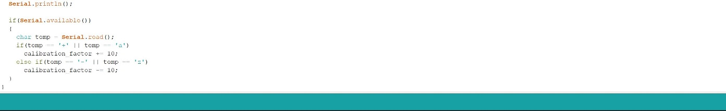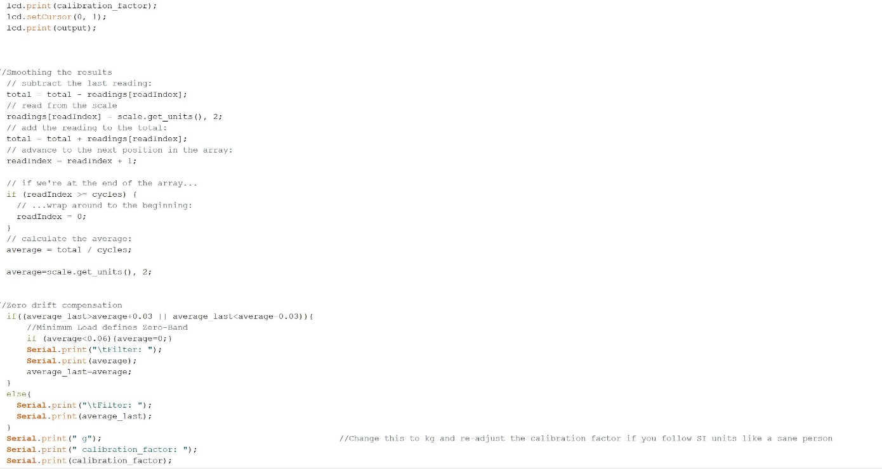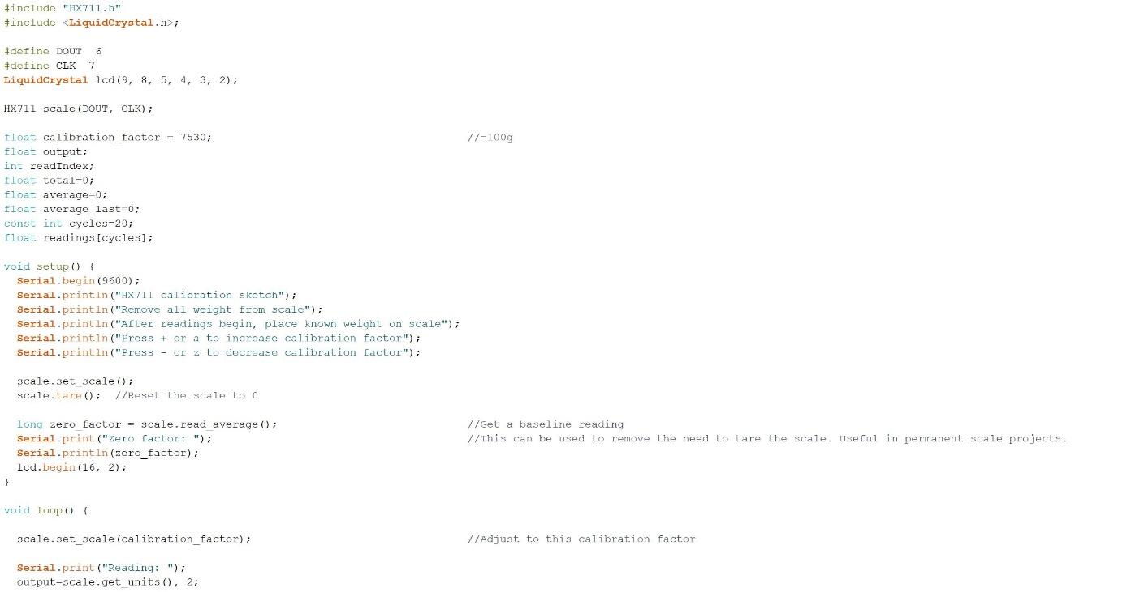

# Appendix B: Load Cell Sketch

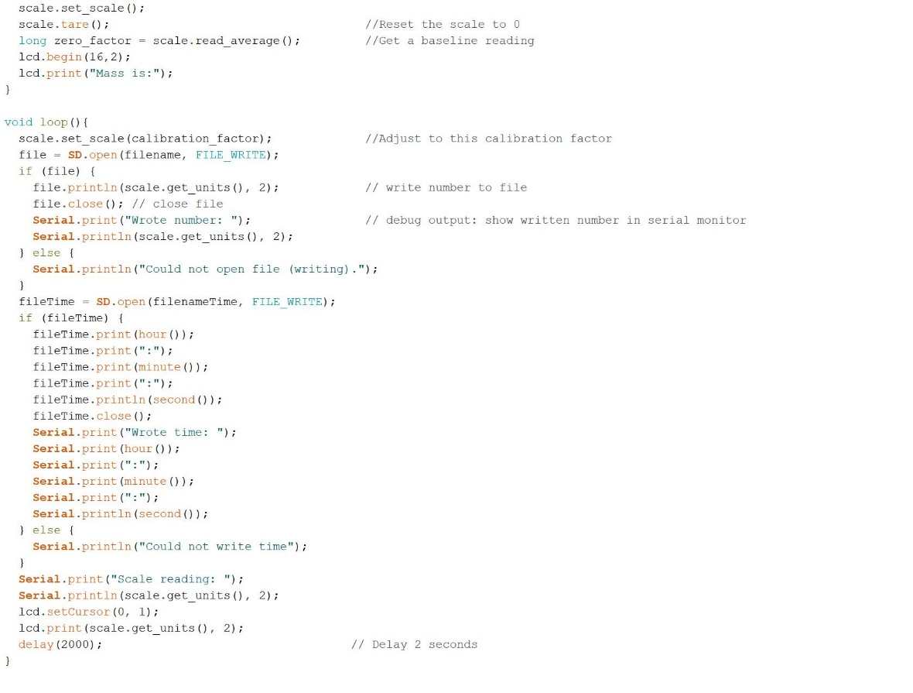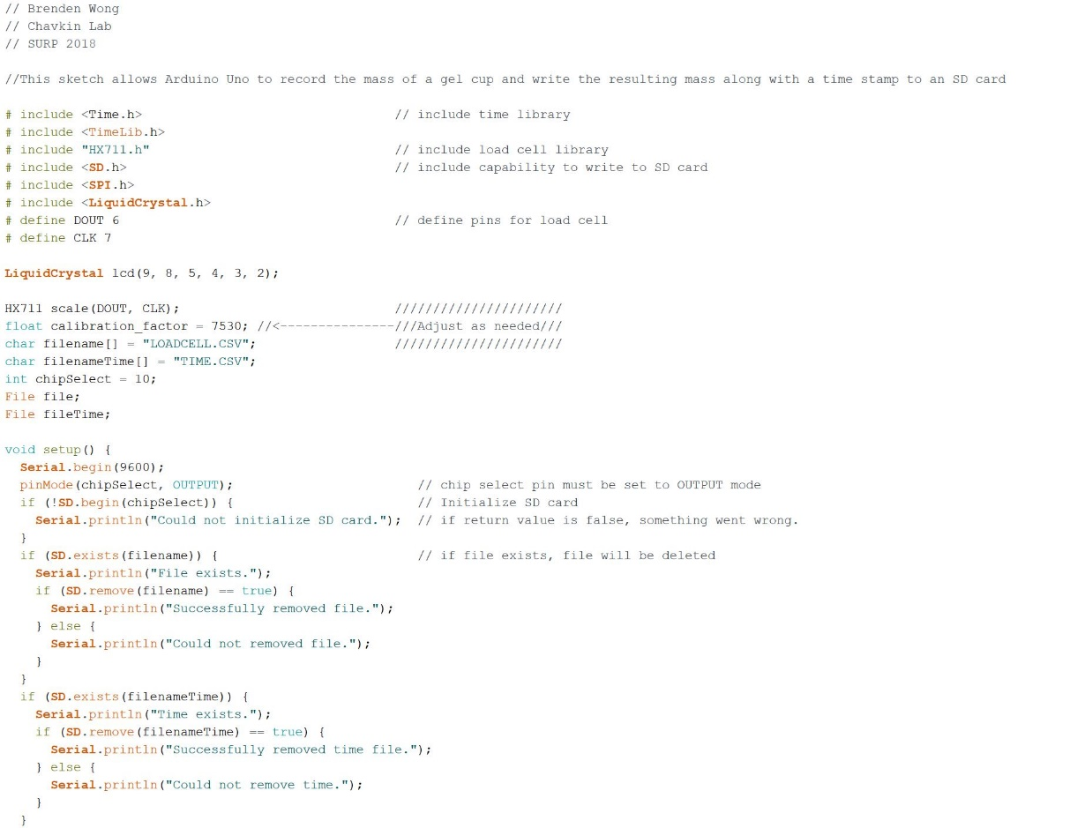

# Appendix C: MATLAB Script

